SOFT-XXXX-XX

ICER Compression Documentation
  - Software Department

Table 1. Document History
Version | Comments | Date | Author | Approved by
V0.01.0 | Created document | 10/07/2026 | Dimitrije
V 1.0 | Finished Main Section | 13/07/2026 | Dimitrije

Table of Contents
Document Purpose 5
Introduction 5
Research 5
Main Body 6
Wavelet Transformations 7
One-Dimensional 7
Two-Dimensional 7
Dynamic Range 8
Bit-Plane Coding 9
Subband Quantization and Priority Factors 10
Context Assignment 10
Probability Estimation 12
Entropy Coding 12
Adaptable Entropy Coding 12
Interleaved Entropy Coding 13
Error Containment 13
ICER Error Containment 14
Choosing the Number of Segments 15
Segment Partitioning 16
Controlling Image Quality and Compression 16
Quality Goal 17
Byte Quota 17
Results 18
Appendix 19
References 19

List of Tables
Table 1. Document History 2
Table 2. Related Documents 5
Table 3. Nomenclature / Acronyms 5

List of Figures
No table of figures entries found.

List of Equations
No table of figures entries found.

Note: Delete List of Figures / List of Equations if there are no figures / equations in the document. Every figure/table referenced in text must be captioned
Table 2. Related Documents
Document Number / Link | Name
SOFT-XXXX-XX | Software Document
https://ipnpr.jpl.nasa.gov/progress_report/42-155/155J.pdf | The ICER Progressive Wavelet Image Compressor
https://github.com/TheRealOrange/icer_compression | Open-Source Implementation

Table 3. Nomenclature / Acronyms
Acronym | Meaning
PAST | Perth Aerospace Student Team
MSB | Most Significant Bit
LSB | Least Significant Bit

Document Purpose
The purpose of this document is to give an overview as to how the ICER Compression algorithm works by explaining the theory in a concise manner.
The audience of this document applies to members looking to integrate the project, further develop this project or learn from this project.

Introduction

Research
Most research for this project was done by reading the NASA ICER document where it outlines in detail the method as to which ICER compresses data. This document will attempt to give a concise overview of all the different steps required to perform ICER compression. For further information it is suggested to read the NASA ICER paper.
For the exact implementation details in code, a separate document is available in the software folder in this repository, under the ICER file where the implementation resides. The ‘reference’ folder holds the open-source implementation while the ‘embedded’ folder holds the actual code that is made for the CubeSat.

Main Body
The ICER compression algorithm is a wavelet-based image compression file format used by the NASA Mars rovers. ICER allows for a trade-off between amount of compression and image quality as specified by the user.
There are many steps required to encode and decode using ICER. In order, these steps are as follows:
- Wavelet Transformations
  - One-Dimensional
  - Two-Dimensional
  - Dynamic Range
- Bit-Plane Coding
  - Subband Quantization and Priority Factors
  - Context Assignment
  - Probability Estimation
- Entropy Coding
  - Adaptable Entropy Coding
  - Interleaved Entropy Coding
- Error Containment
- Controlling Image Quality and Amount of Compression
Here is an overview of each step briefly:
ICER begins by applying an integer wavelet transform to the image, separating it into multiple frequency subbands. This decorrelates neighbouring pixels while preserving invertibility, allowing lossless compression if all transformed data are encoded without loss. Users can choose from several wavelet transforms and specify the number of decomposition levels.
Compared to Discrete Cosine Transform use by JPEG, wavelets avoid blocking artifacts. Although ICER may produce ringing artifacts near sharp edges, these are generally less noticeable and result in better reconstructed image quality.
After the wavelet transformation, ICER performs bit-plane encoding, progressively encoding the transformed coefficients from the most significant bits (MSBs) to the least significant bits (LSBs). During encoding, a context model estimates the probability of each bit, these probabilities are used by an adaptive entropy coder to compress the bitstream.
To improve robustness against transmission errors, the transformed image is divided into independent segments. Each segment is compressed separately, so corruption or loss of one segment affects only that region of image. Increasing the number of segments improves error containment but slightly reduces compression efficiency due to smaller independently coded regions.
Compression is controlled by two user-defined parameters:
Byte quota – limits the maximum compressed file size
Quality goal – stops encoding once the desired image quality is reached
ICER terminates when either the quality goal or the byte quota is reached, proving a trade-off between image quality, compression ratio and transmission reliability.

Wavelet Transformations

One-Dimensional
The one-dimensional wavelet transforms amounts to applying a high-pass/low-pass filter pair and down sampling the results by a factor of 2. The low-pass output represents the image’s coarse, low-frequency information, while the high-pass output captures edges and fine details. A one-dimensional transform produces Low (L) and High (H) components.
ICER uses reversible integer wavelet transforms, allowing the original image to be reconstructed exactly when compression is lossless. Users can choose from several wavelet filters, each providing different compression characteristics.
The one-dimensional transform is the fundamental operation used to construct the two-dimensional transform applied to edges.

Two-Dimensional
The two-dimensional transform is constructed by applying the one-dimensional transform first to every row and then to every column.
Each decomposition stage produces four subbands with the first letter referring to row and the second referring to column – (LL, LH, HL, HH).

After D decomposition levels:
Number of subbands = 3D + 1
The dimensions of the final LL subband become:
(W/2^D) x (H/2^D) where W and H are the original image dimensions
Typically, 3-6 decomposition levels provide the most compression benefit.
Only the LL subband is recursively decomposed because it remains highly correlated and contains most of the image’s energy. Further decomposition exposed redundancy at multiple scales, improving compression efficiency while providing diminishing returns after 3-6 levels.
LH, HL, HH contains mostly edges and fine details. These coefficients are often small or zero, making them highly compressible.
A wavelet coefficient is the value produced by the wavelet transform that represents the strength of a particular frequency component at a specific location in the image.

Dynamic Range
The wavelet transform changes the range of values stored in the image’s pixels. While low-pass filtering performs a weighted average and therefore preserves dynamic range, high-pass filtering computes differences between neighbouring pixels, producing coefficients that may be significantly larger than the original pixel values.
If a coefficient exceeds the storage capacity of its integer representation, overflow occurs. To prevent this, the transformed coefficients must be stored using sufficiently large integer types.
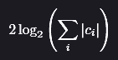
The HH subband is produced by horizontal and vertical filtering, undergoing two high-pass operations. Its approximate dynamic range expansion is therefore:

HH Dynamic Range Expansion 1
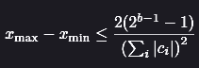
Where ci are the wavelet filter coefficients. To guarantee that overflow does not occur when storing coefficients in a b-bit signed integer, the input image must satisfy:

Where xmax and xmin are the maximum and minimum input pixel values. Natural images rarely produce worst-case coefficient values, making overflow uncommon in practice.

Bit-Plane Coding
After the wavelet transform, ICER converts each wavelet coefficient into a sign-magnitude binary representation, consisting of a sign bit and a sequence of magnitude bits. The coefficients within each subband are conceptually arranged into bit planes, where each bit plane contains the same significance bit from every coefficient (e.g., all MSB, then MSB – 1, then MSB – 2, … lastly LSB).
For improved error resilience, each subband is partitioned into error-containment segments, which are encoded independently (more on this later). Before encoding, the mean value of each LL segment is subtracted and stored in the segment header, reducing the dynamic range of the LL coefficients and improving compression efficiency.
Bit planes are encoded progressively, starting with MSB down to LSB. Since higher significant bits contribute more to value and therefore image data, this allows a partially received bitstream to reconstruct a lower-quality approximation of the image.
Within each segment, coefficients are encoded in raster scan order. The sign bit of a coefficient is transmitted immediately after its first non-zero magnitude bit, avoiding unnecessary encoding of sign bits for zero-valued coefficients.
Before encoding each bit, ICER estimates the probability that the bit is zero using context modelling, which analyses the values of previously encoded neighbouring coefficients within the same subband. Bits with similar neighbourhood characteristics are grouped into the same context, allowing more accurate probability estimates. It is noted that there is no ‘guessing the value of the bit’ with using these probabilities, as will be explained later.
These probability estimates are supplied to an adaptive arithmetic entropy coder, which compresses the bitstream. During decompression, the decoder produces the same context information and probability estimates, enabling the arithmetic coder to recover the original bit sequence exactly.

Subband Quantization and Priority Factors
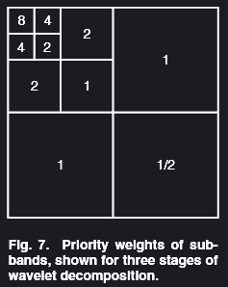
As bit planes are progressively encoded, the reconstructed wavelet coefficients become increase accurate, resulting in a gradual improvement in image quality. Once all bit planes have been received, the original coefficients are reconstructed exactly.
ICER uses a deadzone quantizer, which maps small coefficient values to zero while preserving larger coefficients. Since most coefficients are close to zero, this significantly improves compression efficiency with little impact on visual quality.
ICER also assigns each subband a priority based on its importance to the reconstructed image. Low-frequency subbands, particularly the LL subband, contribute more to overall image quality than high-frequency detail subbands and are therefore encoded first. This prioritization ensures that the most visually important information is transmitted before finer image details, enabling progressive image reconstruction.

Context Assignment
Before encoding each bit, ICER assigns it to a context based on information from previously encoded bits. A context groups together bits with similar characteristics so that the encoder can make a more accurate prediction of whether the next bit is a 0 or 1, improving compression efficiency.
The context is determined using information from the current coefficient and its eight neighbouring coefficients within the same subband segment. Because coefficients are encoded in raster scan order, only previously encoded neighbours are used.
To simplify context assignment, each coefficient is assigned one of four significance categories based on how many of its magnitude bits have already been encoded
Category 0 | coefficient is not yet significant (all encoded magnitude bits are zero).
Category 1 | coefficient has just become significant.
Category 2 | one additional magnitude bit has been encoded.
Category 3 | multiple magnitude bits have been encoded.

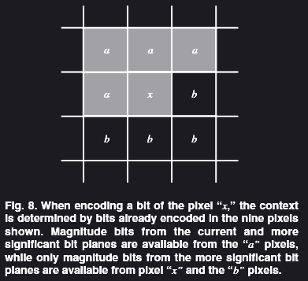
These categories summarize the encoding state of each coefficient without requiring the encoder to examine every previously encoded bit.
Magnitude bits are assigned contexts using the significance of neighbouring coefficients, while sign bits are predicted from the signs of neighbouring coefficients. Rather than encoding the sign directly, ICER encodes whether the actual sign agrees with the predicted sign, further improving compression efficiency.
Bits belonging to coefficients that have reached Category 3 are found to be nearly random and therefore provide little compression benefit. These bits are transmitted without entropy coding.
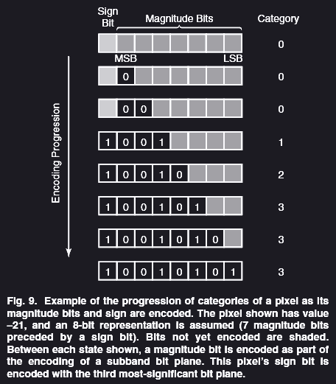

Probability Estimation
For each context, ICER maintains an estimate of the probability that the next encoded bit will be 0. This estimate is based on the recent history of bits previously encoded within that context.
Initially, each context assumes that zeros and ones are equally likely. After each bit is encoded, the probability estimate is updated by incrementing counters that track the number of zeros and the total number of bits observed. As more bits are processed, the probability estimates becomes increasingly representative of the local image statistics.
To prevent older observations from dominating the estimate, the counters are periodically rescaled, reducing their values while preserving the estimated probability. This adaptive approach places greater emphasis on recently encoded bits, allowing the probability model to respond to changes in image characteristics throughout the encoding process.
The estimated probability is passed to the arithmetic entropy coder, which uses it to represent more likely bit values with fewer bits and less likely values with more bits.

Entropy Coding
This section describe the entropy coder used by ICER to compress the magnitude and sign bits of the pixels in the wavelet-transformed image.

Adaptable Entropy Coding
After the context modeler estimates the probability of each bit, the bit and its associated probability are passed to the entropy coder for compression.
An adaptive entropy coder allows the probability estimate to be updated after every encoded bit. This enables the encoder to adapt to changing image statistics and improve compression efficiency throughout the encoding process.
Because the probability model changes continuously, the decoder must reproduce the same probability estimates during decompression. To achieve this, the decoder processes the encoded bits in the same order as the encoder, updating its probability model after each decoded bit.
The reference implementation of ICER uses interleaved entropy coding, an adaptive entropy coding technique chosen for its low computational complexity and encoding speed. It provides compression performance comparable to arithmetic coding while being well suited for resource-constrained systems such as spacecraft.

Interleaved Entropy Coding
ICER uses interleaved entropy coding, an adaptive entropy coding technique that compresses the bitstream using the probability estimates produced by the context model.
Rather than using a single coding scheme for every bit, ICER divides probability estimates into several intervals (bins). Each bin is assigned a component code that is optimized for bits whose probability of being zero falls within that range.
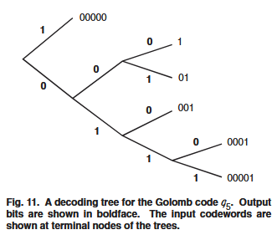
Bits that are equally likely to be 0 or 1 require little or no compression, while bits with a high probability if being zero are assigned to component codes that exploit this bias. For probability estimates greater than approximately 0.853, ICER uses Golomb codes, which efficiently encode long runs of highly probable bit values.
During encoding, bits assigned to the same probability bin are grouped together until they form a complete codeword. The outputs from all component codes are then interleaved into a single compressed bitstream. During decompression, the decoder reproduces the same probability estimates and bin assignment, allowing it to reconstruct the original bit sequence exactly.

Error Containment
ICER incorporates error containment to limit the impact of transmission errors. Since compressed data depends on previously encoded information, the loss of a portion of the compressed bitstream can prevent the decoder from correctly reconstructing subsequent data.
To reduce this risk, the wavelet-transformed image is divided into independent segments, with each segment compressed separately. Corruption or loss of one segment now does not affect the decoding of the remaining segments.
ICER was designed for deep-space missions that use the CCSDS Packet Telemetry Standard. Under this protocol, image data is divided into packets and are transmitted within fixed-size frames. Due to packets having variable lengths while frames have fixed lengths, packet boundaries rarely align with frame boundaries.
Frames are protected by error-correcting codes such as Reed-Solomon or CRC. If a frame contains uncorrectable errors, it is typically discarded entirely rather than partially decoded. Since a lost frame may contain portions of multiple packets, a single transmission error can result in the loss of multiple packets.
To minimise the impact of frame losses, ICER compresses each image segment independently. If packets belonging to one segment are lost, only that segment of the image is affected, while all remaining segments can still be decoded correctly.
The number of segments is user configurable:
- Fewer, larger segments improve compression efficiently by exploiting more redundancy.
- More, smaller segments improve robustness by confining transmission errors to smaller regions of the reconstructed image.

ICER Error Containment
Each compressed segment begins with a segment header containing information required for independent decoding, such as the segment index, image dimension and compression parameters. During transmission, packets are arranged so that each packet contains data from only one segment.
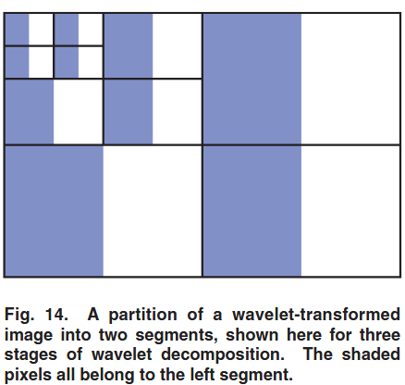
Segmentation occurs after the wavelet decomposition. Each pixel of the transformed image is assigned to a segment. Although segments are defined in the transform domain, each approximately corresponds to a rectangular region of the original image. If s segments are required, first the LL subband is partitioned into s rectangular segments, and then this partition is mapped to other subbands. Thus, pixels in different subbands corresponding to the same spatial location will belong to the same segment.
A consequence of this is that segment boundaries are not sharply defined in the image domain. The effect of data loss in one segment can appear to ‘bleed’ slightly into adjacent segments in the reconstructed image

ICER compresses each segment of a subband bit plane before moving on to the next subband bit plane, each segment will be encoded to nearly the same fidelity. Since each segment is compressed progressively, some error containment occurs naturally within segments.
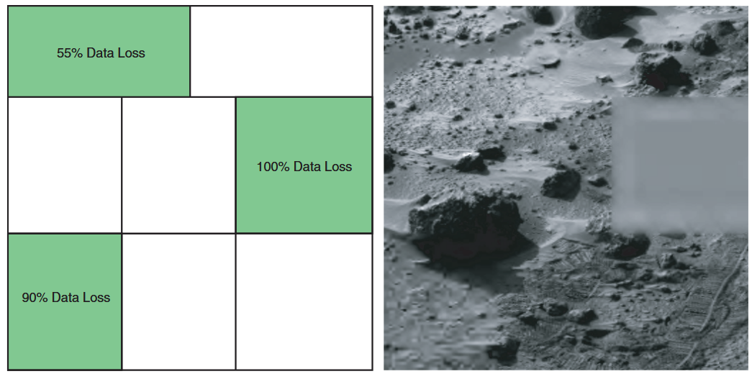
Since each segment is encoded progressively, the packets received before a packet loss can still be used to reconstruct a lower-quality version of the affected segment. Once a packet is lost, however, the decoder cannot decode any subsequent packets belonging to that segment because the required decoding state has been lost. Consequently, an entire segment is lost only if the first packet of that segment is missing.

Choosing the Number of Segments
As segments become very small, the benefit of additional segments diminishes. A single transmission frame is more likely to contain data from multiple segments, allowing one frame loss to affect several segments instead of just one.
The optimal number of segments depends on image size, expected packet loss rate and amount of compressed data transmitted. In general:
- Large images, larger compressed outputs, or less reliable communication channels benefit from more segments.
- Small images or reliable communication channels may use fewer segments or even a single segment to maximise compression efficiency.
A small amount of segmentation can sometimes improve compression performance. Different image regions (sky vs terrain) exhibit different statistical properties. Compression of these regions as separate segments allows the context model to adapt independently to each region, producing more accurate probability estimates.

Segment Partitioning
After defining number of segments, the LL subband is partitioned into rectangular regions. This partition is then mapped directly onto all other subbands, ensuring that coefficients representing the same spatial region belong to the same segment.
The partitioning algorithm is designed to satisfy several objectives:
- Produce approximately square segments, which maximise the number of neighbouring coefficients within each segment and improve compression.
- Create segments of roughly equal area, helping to balance the amount of compressed data contained in each segment.
- Avoid zero-width or zero-height segments.
- Use only integer arithmetic, making it efficient for embedded.
The segment boundaries are not explicitly stored in the compressed bit stream. Instead, both the encoder and decoder independently compute the same partition using the image dimensions, number of wavelet decomposition levels and specified number of segments. These parameters are included in the segment header.

Controlling Image Quality and Compression
ICER’s progressive bitstream allows image quality and compressed size to be controlled independently. Since the image is encoded from MSB to LSB planes, compression can stop at any point while still producing a valid image.
ICER provides two parameters to control compression:
- Byte quota: the maximum number of compressed bytes to produce.
- Quality goal: the desired reconstruction quality.
Compression stops when either one is reached.
This allows us to prioritise either:
- Compression size, by setting byte quota and using a lossless quality goal.
- Image quality, by specifying a sufficiently large byte quota so compression stops when the quality target is reached.

Quality Goal
ICER controls reconstruction quality using the minimum loss parameter (M), which specifies how many of the least important bit planes are omitted during compression. A larger value of M produces higher compression at the cost of lower image quality.
Bit planes are discarded according to their priority, not simply by subband. Less important subbands lose bit planes first, while more important subbands (such as the LL subband) retain more information.
- M = 0: all bits planes are encoded, enabling lossless compression (provided byte quota is large enough).
- Increasing M: More low-priority bit planes are omitted, progressively reducing image quality while improving compression.
Since omitting bit planes effectively increases the quantization step size, large values of M produce coarser coefficient reconstruction and greater image distortion.

Byte Quota
The byte quota specifies the target maximum size of the compressed output. ICER monitors the compressed size during encoding and stops when either byte quota or quality goal is reached.
Because ICER checks the byte quota only after completing an error-containment segment of a subband bit plane and the entropy coder must flush any buffered data before finishing, the final compressed size may slightly exceed the specified byte quota. This overshoot is generally small.
If an exact output is required, the compressed bitstream can be truncated. Since ICER compresses every error-containment segment progressively, the output stream interleaves data from all segments. Truncating the overall bitstream therefore reduces image quality approximately uniformly across the entire image, rather than discarding complete regions.
Before transmission, the interleaved blocks are reordered so that all data belonging to the same error-containment segment is continuous. This reduces the likelihood that a single packet or frame loss will affect multiple segments.
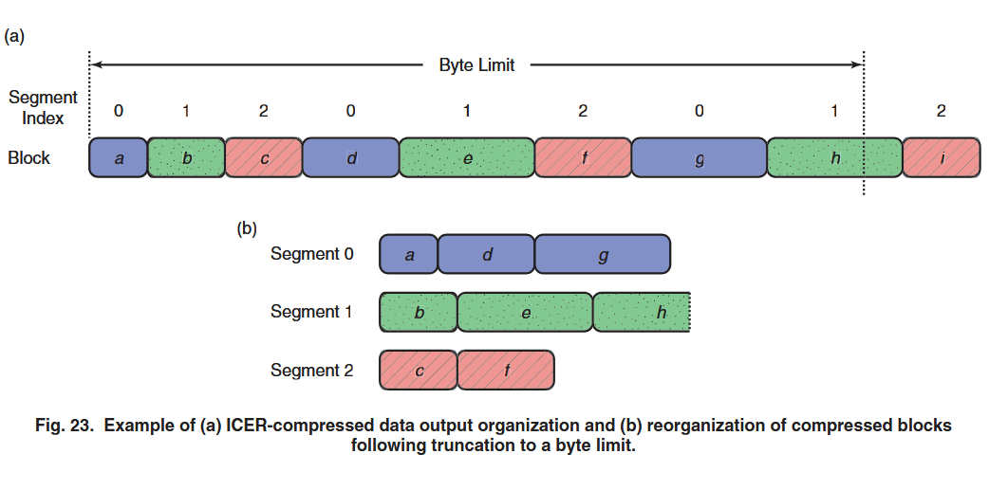

Results
ICER was evaluated using six 12-bit Mars Pathfinder images and compared its performance and other algorithms such as JPEG 2000, JPEG, LOCO and Rice coding.
For lossy, ICER achieved image quality comparable to JPEG 2000 while outperforming traditional JPEG at the same bit rates.
For lossless compression, ICER achieved compression ratios comparable to LOCO, a then state-of-the-art lossless compressor, while outperforming both JPEG 200 and the Rice compressors used in previous Mars missions.
Compression benchmarks on the 20 MHz RAD6000 processor used by Mars Exploration Rovers showed that ICER is computationally efficient. Compression time decreases as fewer bytes are produced because the encoder stops once the desired quality or byte quota is reached. The wavelet transform accounts for most of the processing time, while the choice of wavelet filter or number of decomposition levels has relatively little effect on overall speed.

Appendix

References

